 | 7.3.13 Editors - 3D Viewport - Sidebar - Tool Tab - Grease Pencil - Vertex Paint Mode
Table of content
Grease Pencil - Vertex Paint Mode 2
Brush Asset Panel 2
Browse Brush 2
Brush Specials menu 2
Edit Metadata 2
Catalog 2
Author 2
Desctription 2
OK / Cancel 3
Edit Preview Image 3
Save Brush Asset 3
Revert Brush Asset 3
Name 3
Brush Settings Panel 3
Radius 3
Use Pressure 3
Strength 3
Use Pressure 3
Brush Settings Panel - Cursor Sub panel 4
Show Brush 4
Color 4
Color Panel 4
Material / Vertex Color 4
Color picker 4
Active color 4
Brush colors flip 4
Mode 4
Mix Factor 5
Color Panel - Palette sub panel 5
Palette browser 5
Edit Box 5
Number of users 5
Fake User 5
Add palette 5
Remove Palette 5
New Palette color 6
Delete Palette color 6
Move Palette Color up and down 6
Sort By 6
Palette Colors 6
Falloff Panel 6

Grease Pencil - Vertex Paint Mode

In draw mode you can paint whole strokes with vertex color. In Vertex Paint mode you can paint the single vertices of a stroke with vertex color.

Brush Asset Panel
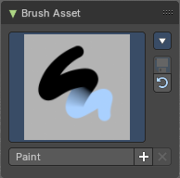
The Brush Asset Panel contains the different Brushes and some Brush settings. Choose and adjust your current active brush.

Browse Brush
The big image at the top is a dropdown box that allows you to choose a brush. Click at it, and you will see the different brushes. A click at one of the images will choose this brush then.
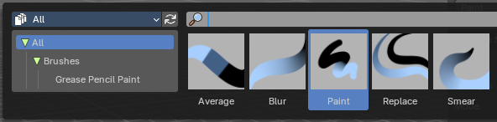
Brushes are assets. You can load them from different libraries if you want.

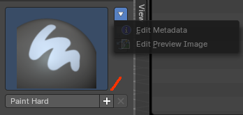
Brush Specials menu
This menu becomes active when you create a new brush. Which can be done wiht the Plus button in the name property. This data cannot be changed for builtin system brushes.

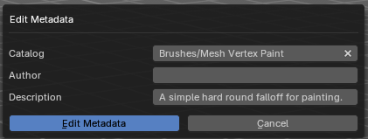
Edit Metadata
Calls a popup where you can adjust further informations and settings for the brush.

Catalog
The asset catalog in which the brush is stored.

Author
The brush author.

Desctription
Add a description

OK / Cancel
Accept or decline the changes.

Edit Preview Image
Allows you to load a custom preview image.

Save Brush Asset
This button is just active with a custom brush. It saves all changes made at the brush settings into the current custom brush.

Revert Brush Asset
Reverts the brush settings to the default values of the brush in the asset library.

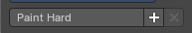
Name
The edit box below the Image shows the name of the current active brush.
The + button allows you to add a new pencil with the current settings. Note that the brushes are NOT automatically saved when you close Bforartists. You need to save the brush asset. See above.
The X button deletes the brush from the brushes list and from the asset library. This button is just active with a custom brush. You will be prompted by a warning so that you don't accidentally remove the brush.
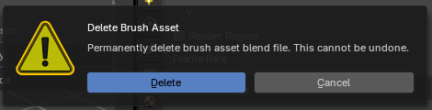

Brush Settings Panel

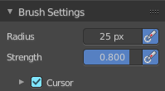
Radius
The radius of the brush.

Use Pressure
Use tablet pressure.

Strength
The strength of the brush.

Use Pressure
Use tablet pressure.

Brush Settings Panel - Cursor Sub panel
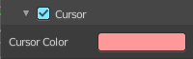

Show Brush
Show the brush icon when painting.

Color
The brush icon color.

Color Panel
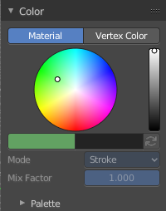
The default grease pencil color is based at materials. And then this panel is greyed out and dysfunctional. But you can also choose to work with vertex colors instead. And then all the color panel features becomes activated.

Material / Vertex Color
Choose if you want to work with material based colors or with vertex colors. Turn it to vertex colors to activate the features.
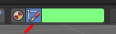
This can also be done in the tool settings in the header.

Color picker
Define the color for your brush.

Active color
The active color is the left one. When you click the button with the two arrows down right then you can swap the color with the secondary color. Then this secondary color becomes the primary color, and is active.
A click at one of the color fields will open a more detailed color dialog, where you can set up the color by using rgb, hsv and hex colors and with value sliders.

Brush colors flip
Flips the primary color with the secondary color.

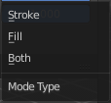
Mode
How the vertex color is applied.

Mix Factor
Factor used to mix the vertex color to get final color.

Color Panel - Palette sub panel

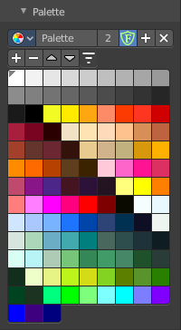
Here you will find a predefined color palette, and here you can create a color palette for later reuse.
The color palette cannot be saved externally. It is part of the current blend file. You can however append color palettes from other blend files.
The currently active color is the one with the triangle at it.

The elements are explained from left to right and from top to bottom.

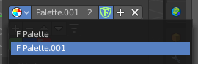
Palette browser
The button at the left opens a drop down list to choose between your palettes.

Edit Box
Read the name of the currently active palette. You can also rename the palette here. A click into the edit box makes the name editable.

Number of users
The number of users the palette currently has.

Fake User
Fake User sets the element to have a fake user. Zero user data-blocks are normally not saved. But sometimes you want to force the data to be kept even when the data block has no user.

Add palette
Add a new palette.

Remove Palette
Clicking at this button removes the palette. Note that you need to save, close Bforartists and reload the blend file to remove the palette completely.

New Palette color
Adjust a color in the color picker. Then click at the add button to add this color to the palette.

Delete Palette color
Select the color in the palette, then click at the minus button to remove it.

Move Palette Color up and down
With these two buttons you can move the active color up or down in the palette.

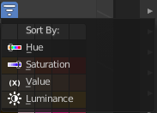
Sort By
Sort the palette by different methods.

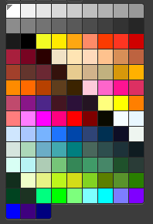
Palette Colors
The actual list of the current palette colors. Click at one to make it the active one that gets used for painting.

Falloff Panel

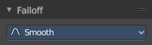
Adjust the brush falloff.

